During the Storm

The safety of you and your family is the most important consideration. Since floodwaters can rise very rapidly, you should be prepared to evacuate before the water level reaches your property. During the storm, the following tips may be helpful: Be informed: Know evacuation routes, and listen to local authorities when asked to evacuate. Everyone should know their risks.

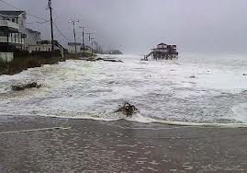

Keep a battery-powered radio tuned on. During significant storm events warnings will be broadcast on the Government Access Channel (Cable Channel 191), radio stations (92.5 FM, 95.3 FM, 99.1 FM, 104.1 FM, 105.7 FM & NOAA weather radio), television (Cable Channel 190, Weather Channels 57, Virginia Channels 3, 10, and 13, and North Carolina Channels 7 and 9). The following websites are other valuable resources for up to date information on the storm: (www.darenc.com); (www.outerbanksvoice.com); www.ncready.org; and www.nhc.noaa.gov. Follow emergency instructions as they are given. If you are unable to evacuate, go to your safe room. If you do not have one, follow these guidelines. Stay indoors during a hurricane and away from windows and glass doors. Close all interior doors. Secure and brace external doors. Keep curtains and blinds closed. Do not be fooled if there is a lull - it could be the eye of the storm and winds will pick up again. Take refuge in a small interior room, closet, or hallway on the lowest level. Lie on the floor under a table or another sturdy object. Keep warm clothing, a flashlight and a portable radio with you. Then wait for help. Don't try to swim to safety. Rescue teams will look for you.

If, and only if, time permits . . . there are several precautionary steps that can be taken:
Turn off all utilities at the main power switch and close the main gas valve if evacuation appears necessary. Move valuable items to upper floors or higher elevations. Fill bathtubs, sinks, and jugs with clean water in case regular supplies are contaminated. You can sanitize these items by first rinsing in bleach. Board up windows or protect them with storm shutters to prevent broken glass. Bring outdoor possessions inside the house or tie them down securely. This includes lawn furniture, garbage cans, tools, and other movable objects that might be swept away or hurled about. Stock the car with blankets, a first aid kit, flashlights, dry clothing, and any special medication needed by your family. Park the car in an area safe from rising waters.

Important things you DO NOT do during a flood

When outside the house, remember: WATER DEPTHS DURING FLOODS ARE DECEPTIVE. Try to avoid flooded areas, and DO NOT attempt to walk through floodwaters that are more than knee deep. DO NOT drive where water is standing on the road. Parts of the road may already be washed out. If your car stalls in a flooded area, DO NOT remain in the car. Abandon it as soon as possible and seek higher ground. Floodwaters can rise rapidly and sweep a car (and its occupants) away. Many deaths have resulted from attempts to move stalled vehicles. Avoid areas subject to sudden flooding. DO NOT try to cross a flowing stream where water is above your knees. You could be swept away by strong currents. DO NOT sightsee in flooded areas and DO NOT make unnecessary trips.

After a Storm

Potential problems include flooding, polluted water, limited communications, no electricity, blocked roads, septic/sewer failure, damage to structures, and severe erosion to shorelines. After a storm passes, powerful waves and ocean currents may persist for several days, causing additional flooding, coastal erosion, structural damage, and riptides.

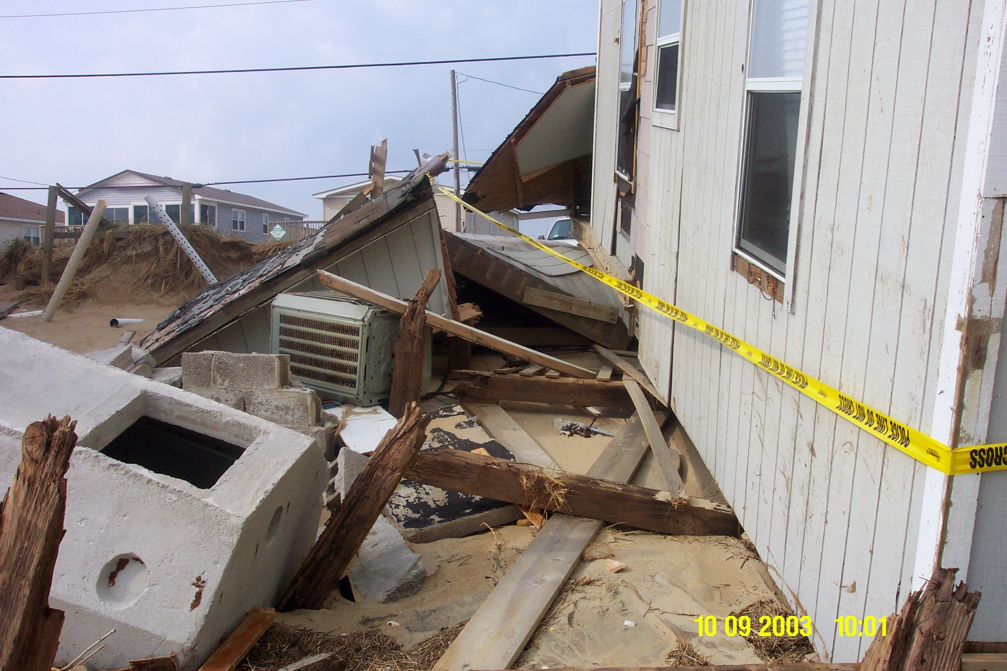

Potential problems include flooding, polluted water, limited communications, no electricity, blocked roads, septic/sewer failure, damage to structures, and severe erosion to shorelines. After a storm passes, powerful waves and ocean currents may persist for several days, causing additional flooding, coastal erosion, structural damage, and riptides.

During the aftermath of a flooding event, follow these steps to aid your family's safety: Before entering a building, check for structural damage. Make sure it is not in danger of collapsing. Turn off any outside gas lines at the meter or tank, and let the house air for several minutes to remove foul odors or escaping gas. Avoid downed power lines and broken gas lines. Report them immediately to the electric or gas company, police or fire department. Upon entering the building, DO NOT use an open flame as a light source since gas may be trapped inside. A battery-operated flashlight is ideal. DO NOT handle live electrical equipment in wet areas. If appliances or electrical equipment have been in contact with water, have them checked before use. Use the telephone only for emergencies or to report dangerous conditions.

Information from www.fema.gov, www.floodsmart.gov & www.ready.gov

