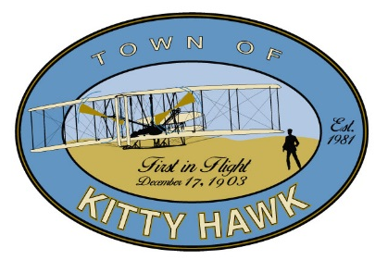
Post Office Box 549
101 Veterans Memorial Drive
Kitty Hawk, NC 27949
Phone (252) 261-3552
Fax (252) 261-7900
www.townofkittyhawk.org

Kitty Hawk Planning Board Meeting,

September 17, 2015 ~ 6:00 p.m.
Kitty Hawk Municipal Building

Agenda

- Call to Order/Attendance

- Approval of Agenda

- Approval of Minutes:
- August 13, 2015

- Administrative Report:
  - Town Council Action from 9/8 Meeting

- Conditional Use Permit:
  - Medical office/clinics in BC-2. 5107 N. Croatan Hwy

- Site Plan Review:
  - Atlantic Dentistry. Revised site plan for Atlantic Dentistry, located at 3704 N. Croatan Hwy

- Text Amendment:
  - Conditional Zoning. The Board will review and discuss the concept of Conditional Zoning.

- Comments:
- Chairwoman McClean
- Planning Board Members
- Town Attorney
- Planning Director

- Public Comment

- Adjourn

