Post Office Box 549
101 Veterans Memorial Drive
Kitty Hawk, NC 27949
Phone (252) 261-3552
Fax (252) 261-7900
www.townofkittyhawk.org
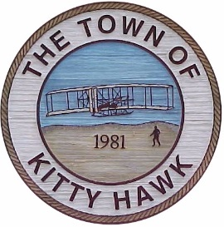

Kitty Hawk Planning Board Meeting,

June 15, 2017 ~ 6:00 p.m.
Kitty Hawk Municipal Building

Agenda

- Call to Order/Attendance

- Approval of Agenda

- Approval of Minutes:
- February 16, 2016

- Administrative Report:
  - Town Council Action from 3/6 meeting

- Public Comment

- Text Amendment:
  - 42-1 Definitions. Applicant is seeking to amend the definition of lot coverage to allow for a lot coverage bonus when permeable pavement is used.
  - 42-415. Outdoor Lighting; Division 3, Signs, Table V. Proposed amendment would amend standards for internally illuminated signage.

- Subdivision Variance:
  - 4100 Block of Lindbergh Avenue. The applicant is seeking a subdivision variance to revert lots to original configuration.

- Comments:
- Chairman Richeson
- Planning Board Members
- Town Attorney
- Planning Director

- Adjourn

