Post Office Box 549
101 Veterans Memorial Drive
Kitty Hawk, NC 27949
Phone (252) 261-3552
Fax (252) 261-7900
www.townofkittyhawk.org
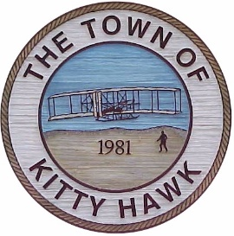

Kitty Hawk Planning Board Meeting,

October 26, 2017 ~ 6:00 p.m.
Kitty Hawk Municipal Building

TOWN of
KITTY HAWK
PUBLIC NOTICE

The Kitty Hawk Planning Board will meet on October 26, 2017 to consider the same agenda item(s) as published for the October 12th planning board meeting.

Agenda

- Call to Order/Attendance

- Approval of Agenda

- Approval of Minutes:
- August 17, 2017

- Administrative Report:
  - Town Council Action from 9/5 and 10/2 meetings

- Public Comment

- Text Amendment:
  - 42-1, 42-528.The applicant is seeking a text amendment that would allow residential lots to contain one accessory dwelling unit (either attached or detached) on a residential lot.

- Comments:
- Chairman Richeson
- Planning Board Members
- Town Attorney
- Planning Director

- Adjourn

