Storm Warning System

During times of crisis in Dare County and/or the Town of Kitty Hawk, decisions relating to evacuation, re-entry, state of emergency declarations, etc., are made by the County’s control group. The responsibility for ordering a countywide evacuation rests with the Dare County Control Group. The Dare County and Town of Kitty Hawk emergency warning system is designed to provide residents with up to a 72-hour advance warning of flooding hour advance warning of flooding within the 100-year floodplain.

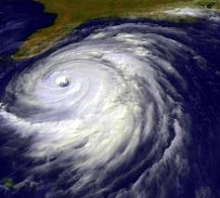

However, flooding can occur quickly and without much prior warning. You should follow the instructions and warnings as they are given, rather than delaying to see if flooding actually occurs.

During significant storm events warnings will be broadcast on the Government Access Channel (Cable Channel 191), radio stations (92.5 FM, 95.3 FM, 99.1 FM, 104.1 FM, 105.7 FM & NOAA weather radio), television (Cable Channel 190, Weather Channels 57, Virginia Channels 3, 10, and 13, and North Carolina Channels 7 and 9). The Dare County website (www.darenc.com) and the Outer Banks Voice website (www.outerbanksvoice.com) are other valuable resources for up to date information on storm tracking. Residents may also be informed by emergency personnel (Fire and Police Departments) going door to door or by the Dare County public address system. If a power outage occurs, tune to local radio stations for information about the Town of Kitty Hawk and surrounding areas.
Evacuation

Evacuation areas will be determined by the projected storm related conditions as supplied by the National Hurricane Center. Persons should leave promptly once an evacuation order is given; visitors should take all belongings with them. All resident and non-resident property owners should plan to have their property secured prior to the onset of gale force winds (40 MPH). Evacuation will be completed during daylight hours.

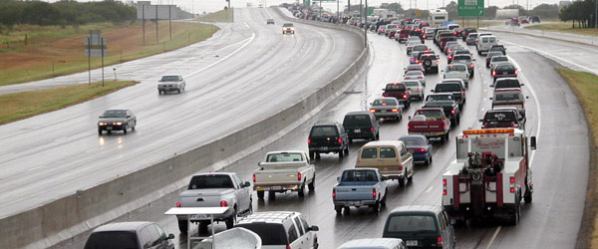

Evacuation route signs are in place to assist motorists. Public information statements are routinely issued by Emergency Management on local radio (WRSF 105.7 & WCXL 104.1 - Official Dare County Emergency Alert System Stations), television stations, and the county website (www.darenc.com) to provide timely weather information and local condition reports. Law enforcement officers will be at traffic control points.

The Town’s Emergency Operations Center (EOC) serves as the central direction and control point for Town-wide emergency response activities. The EOC will be located at Kitty Hawk Town Hall, 101 Veterans Memorial Drive, or the Kitty Hawk Fire Department, 859 West Kitty Hawk Road.

Storm Preparation: Steps to Take Today

During an emergency, your personal safety is more important than your most valuable property. Take steps now to help your family prepare for an emergency. Store these supplies in a safe, accessible location: first aid kit and essential medicine, water and non-perishable food (include
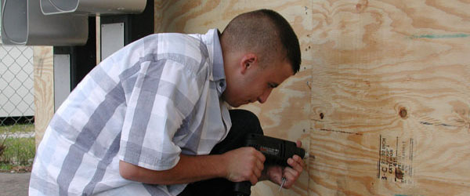

baby food and food for special diets), portable radio, flashlights, extra batteries, and non-electric can opener. Persons
who live in frequently flooded areas should keep on hand materials such as sandbags, plywood, plastic sheeting, and
lumber which can be used to protect property. Remember, sandbags should not be stacked against the outer walls of a building since, when wet, the bags may create added pressure on the foundation.

You will need to make plans to secure your property. Replace windows with impact glass, install permanent storm shutters, or board up windows with 5/8” marine plywood, cut to fit and ready to install. Tape does not prevent windows from breaking. Install straps or additional clips to securely fasten your roof to the frame structure, which will reduce roof damage. Make sure trees and shrubs around your home are well trimmed so they are more wind resistant. Clear loose and clogged rain gutters and downspouts. Reinforce your garage doors. Make plans to bring in all outdoor furniture, decorations, garbage cans and anything else that is not tied down. Determine how and where to secure your boat. Install a generator for emergencies. Consider building a safe room.

Buy flood insurance. Property owners can insure their buildings and contents, and renters can insure their possessions. Keep in mind, there is a 30-day waiting period before a flood insurance policy takes effect, so do not get caught applying for flood insurance the day before a storm. For more information, call your local insurance agent or the NFIP at (800) 621-FEMA or visit www.floodsmart.gov. Property owners can insure their buildings and contents, and renters can insure their possessions. Keep your insurance policies and a list of personal property in a safe place, such as a safety deposit box. Know the name and location of the agent(s) who issued these policies.

Create a family emergency plan: Know what to do if you have to evacuate. Make sure you know how to contact members of your family and have an emergency contact number for someone out of state who knows where you are in the event of an emergency. Make sure your pet is included in your emergency plan. Shelters do not have staff or facilities to care for animals. Frightened pets may be injured or killed during severe storms. To look for pets after a storm, call the Dare County Animal Shelter at (252) 475-5620. You may want to offer assistance to an elderly or disabled family member or neighbor that may be alone and may need your help during an emergency. Make your plans ahead of time and practice them.

Be informed: Know evacuation routes, and listen to local authorities when asked to evacuate. Everyone should know their risks. People should have disaster plans and be ready to vacate their residence when advised by local authorities. Determine where you would go and how you would get there if you needed to evacuate.

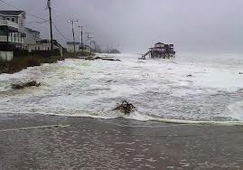
During the Storm

The safety of you and your family is the most important consideration. Since floodwaters can rise very rapidly, you should be prepared to evacuate before the water level reaches your property. During the storm, the following tips may be helpful: Keep a battery-powered radio tuned to a local station and/or tune into Government Access Channel (Cable Channel 20 or WRSF 105.7 FM radio). Follow emergency instructions as they are given. If you are unable to evacuate, go to your safe room. If you do not have one, follow these guidelines.

Stay indoors during a hurricane and away from windows and glass doors. Close all interior doors. Secure and brace external doors. Keep curtains and blinds closed. Do not be fooled if there is a lull - it could be the eye of the storm and winds will pick up again. Take refuge in a small interior room, closet, or hallway on the lowest level. Lie on the floor under a table or another sturdy object. Keep warm clothing, a flashlight and a portable radio with you. Then wait for help. Don't try to swim to safety. Rescue teams will look for you.

If, and only if, time permits . . . there are several precautionary steps that can be taken:

Turn off all utilities at the main power switch and close the main gas valve if evacuation appears necessary. Move valuable items to upper floors or higher elevations. Fill bathtubs, sinks, and jugs with clean water in case regular supplies are contaminated. You can sanitize these items by first rinsing in bleach. Board up windows or protect them
with storm shutters to prevent broken glass. Bring outdoor possessions inside the house or tie them down securely. This includes lawn furniture, garbage cans, tools, and other movable objects that might be swept away or hurled about.
Stock the car with blankets, a first aid kit, flashlights, dry clothing, and any special medication needed by your family. Park the car in an area safe from rising waters.

Important things you DO NOT do during a flood

When outside the house, remember: WATER DEPTHS DURING FLOODS ARE DECEPTIVE. Try to avoid flooded areas, and DO NOT attempt to walk through floodwaters that are more than knee deep. DO NOT drive where water is standing on the road. Parts of the road may already be washed out. If your car stalls in a flooded area, DO NOT remain in the car. Abandon it as soon as possible and seek higher ground. Floodwaters can rise rapidly and sweep a car (and its occupants) away. Many deaths have resulted from attempts to move stalled vehicles. Avoid areas subject to sudden flooding. DO NOT try to cross a flowing stream where water is above your knees. You could be swept away by strong currents. DO NOT sightsee in flooded areas and DO NOT make unnecessary trips.
After a Storm

Potential problems include flooding, polluted water, limited communications, no electricity, blocked roads, septic/sewer failure, damage to structures, and severe erosion to shorelines. After a storm passes, powerful waves and ocean currents may persist for several days, causing additional flooding, coastal erosion, structural damage, and riptides. Potential problems include flooding, polluted water, limited communications, no electricity, blocked roads, septic/sewer failure, damage to structures, and severe erosion to

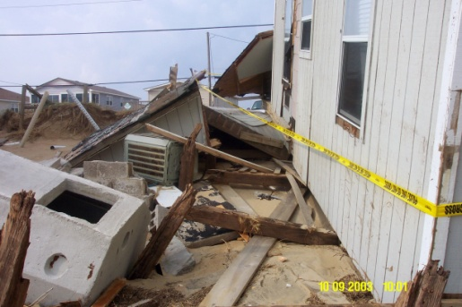

shorelines. After a storm passes, powerful waves and ocean currents may persist for several days, causing additional flooding, coastal erosion, structural damage, and riptides.

During the aftermath of a flooding event, follow these steps to aid your family's safety: Before entering a building, check for structural damage. Make sure it is not in danger of collapsing. Turn off any outside gas lines at the meter or tank, and let the house air for several minutes to remove foul odors or escaping gas. Avoid downed power lines and broken gas lines. Report them immediately to the electric or gas company, police or fire department. Upon entering the building, DO NOT use an open flame as a light source since gas may be trapped inside. A battery-operated flashlight is ideal. DO NOT handle live electrical equipment in wet areas. If appliances or electrical equipment have been in contact with water, have them checked before use. Use the telephone only for emergencies or to report dangerous conditions.

Information from www.fema.gov, www.floodsmart.gov & www.ready.gov

